Database Project

Hospital management system

**Entities:**

1. Patient

2. Ward

3. Consultant

4. Nurses

5. Medicine  
  
**Attribute:**

Patient –

Patient ID, Name, Address, Contact number, Insurance/health coverage, ward ID, consultant ID, Medicine Id

Ward –

Ward ID, Ward Name, Location, Cost, Patient ID, Ailment, Nurse type (Ward Sister ID, regular nurse ID), Ward type (public ward, private ward), beds

Medicine –

Medicine Id, Medicine Name, Patients Id, cost, nurse id, consultant id, Dosage

Consultant –

Consultant Id, consultant name, contact, cost, Patients ID, review of patient condition.  
  
Nurses –

Nurse Type (Ward Sister ID, regular nurse ID), Nurse name, contacts, Patients ID, Ward Id

**Relations:**

Patients are ADMITTED TO a ward M:1

Patients are SEEN BY a Consultant M:1

Nurses are ASSIGNED TO a ward M:1

Medicines are DESPENSED DAILY to Patients M:M

Consultants are ASSIGNED TO a ward M:1

Conceptual Diagram

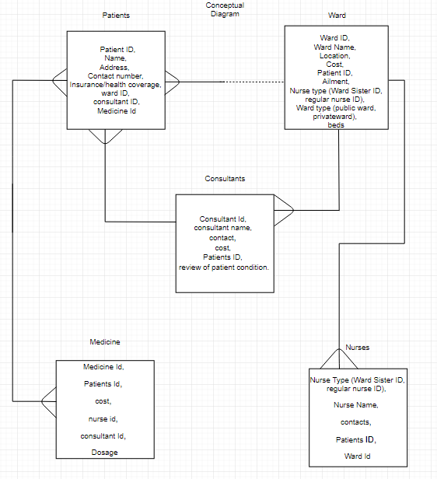

Logical Diagram

